Towards partial fulfillment for Undergraduate Degree Level Programme
Bachelor of Technology in Computer Science and Engineering

Summer Internship Evaluation Report on: Full Stack Web Developer

Prepared by:

Name of the Student: | SOURABH PATEL
Admission No.: | U19CS082
Class: | B.TECH. IV (Computer Science and Engineering)  Semester - 7
Year: | 2022-23
Name and Address of the Company where internship is done: | ERENTALS HND PVT LTD  Headquarters:  314, IITB-Monash Building , IIT Bombay, Mumbai, Maharashtra 400076, IN
Name and Designation of the Mentor  (from Company): | Mr. SADDAM HUSSAIN  (Cofounder, CTO)
Name of the Mentor  (from SVNIT): | Dr. BALU L PARNE


DEPARTMENT OF COMPUTER SCIENCE AND ENGINEERING
SARDAR VALLABHBHAI NATIONAL INSTITUTE OF TECHNOLOGY,
SURAT - 395007 (GUJARAT, INDIA)

Student Declaration

This is to certify that the work described in this summer internship report has been actually carried out and implemented by me i.e.

Admission No. | Student Name
U19CS082 | SOURABH PATEL

Neither the source code there in, nor the content of the project report have been copied or downloaded from any other source. We understand that our result grades would be revoked if later it is found to be so.

Signature of the Student:

i

Certificate

This is to certify that the summer internship report entitled Full Stack Web Developer is prepared and presented by,

Admission No. | Student Name
U19CS082 | SOURABH PATEL

Final Year of Computer Science and Engineering and his/her work is satisfactory.

SIGNATURE:

MENTOR JURY HEAD OF THE DEPARTMENT

ii
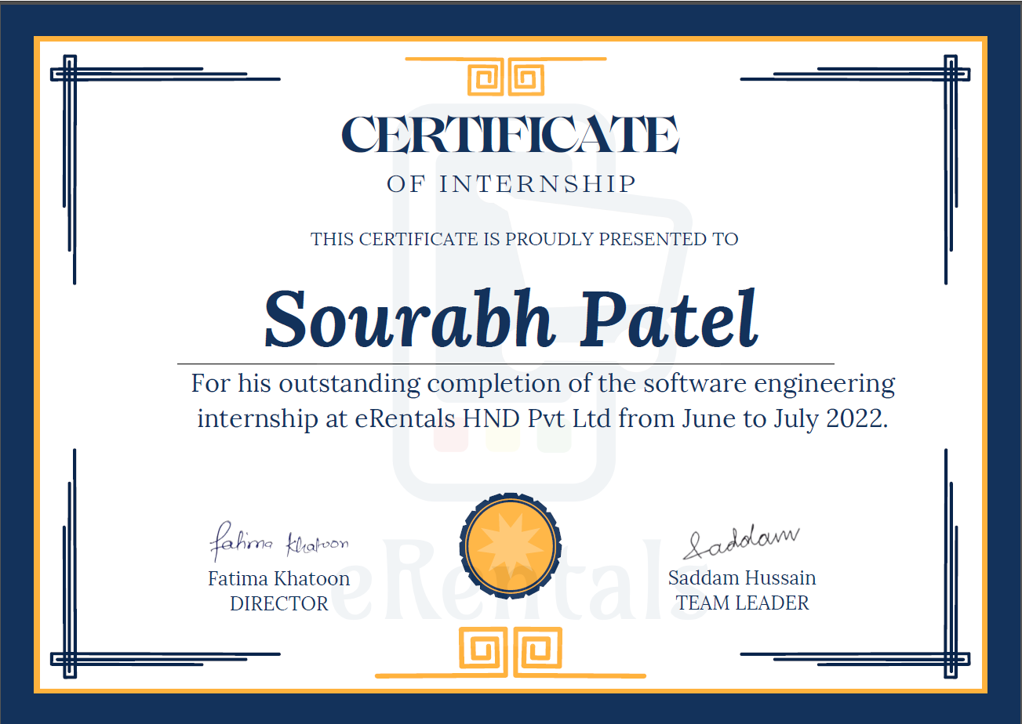

iii

